[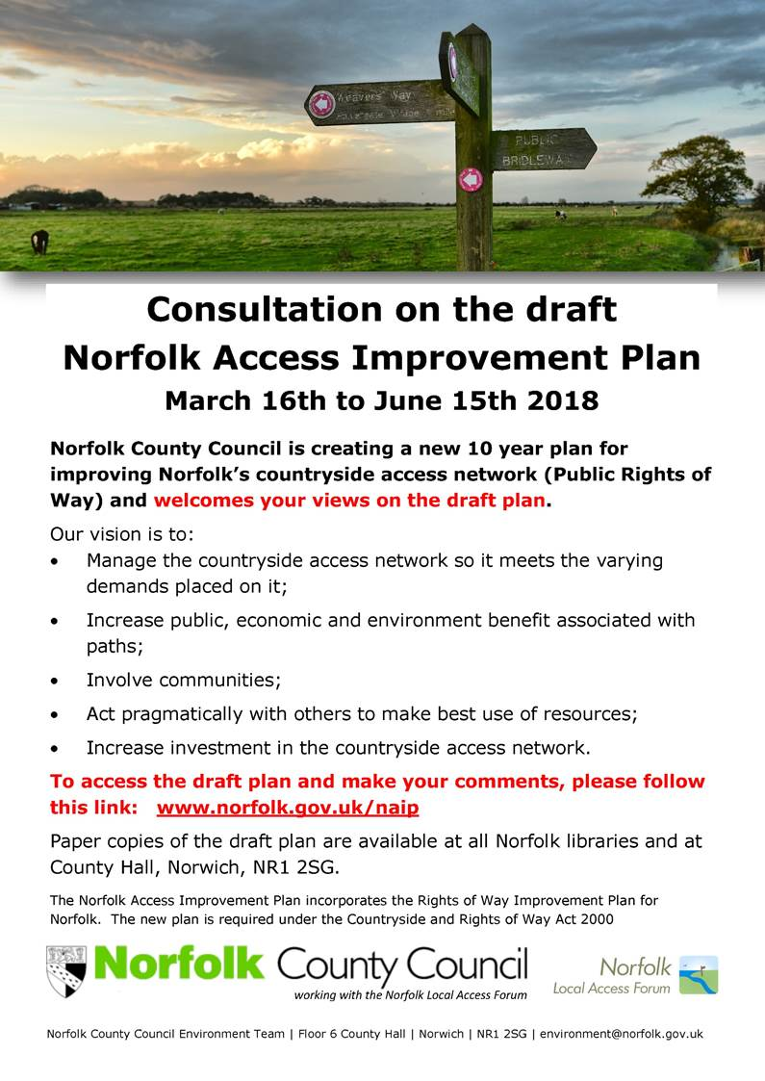](http://www.norfolk.gov.uk/naip)